**Programming fundamentals**

**Lab assignment 4**

**QUESTION#1:**

**Write a C program to check whether a number is multiple of 3 or not. If it is then print “This number is multiple of 3”, otherwise print “This number is not multiple of 3”**

**Source code:**

**Output:**

**QUESTION#2:**

**Create a calculator asking for operator (+ or – or * or /) and operands and performs calculation according to the user input using switch statement.**

**Source code:**

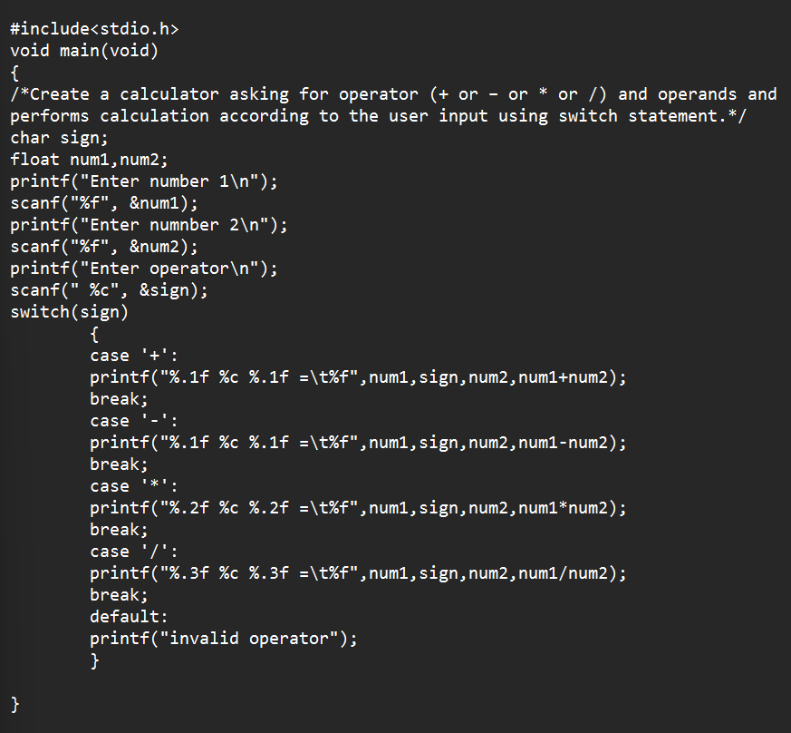

**Output:**

**QUESTION#3:**

Write a C program to input a character from the user and check whether the given character is a small alphabet, capital alphabet, digit, or special character,

using if else.

**Source code:**

**Output:**

**QUESTION#4:**

An online shopping store is providing discounts on the items due to the Eid. If the cost of items is less than 2000 it will give a discount up to 5%. If the cost of shopping is 2000 to 4000, a 10% discount will be applied. If the cost of shopping is 4000 to 6000, a 20% discount will be applied. If ita more than 6000 then a 35% discount will be applied to the cost of shopping. Print the actual amount, saved amount and the amount after discount. The Minimum amount eligible for a discount is 500.

**Source code:**

**Output:**

**QUESTION#5:**

Write a program in C to calculate and print the Electricity bill of a given customer. The customer id., name and unit consumed by the user should be taken from the keyboard and display the total amount to pay to the customer.

**Source code:**

**Output:**

**Question#6:**

**Given a positive integer denoting n, do the following:**

**a. If 1<=n<=9, print lowercase English words corresponding to the numbers e.g. (one for 1, two for 2)**

**b. If n>9 print greater then 9**

**Source code:**

**Output:**

